Image | 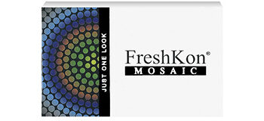
Brand | TIFFANY & CO.
Model Name | FRESHCON MOSAC
Price | RS 4000
PRODUCT DETAILS

